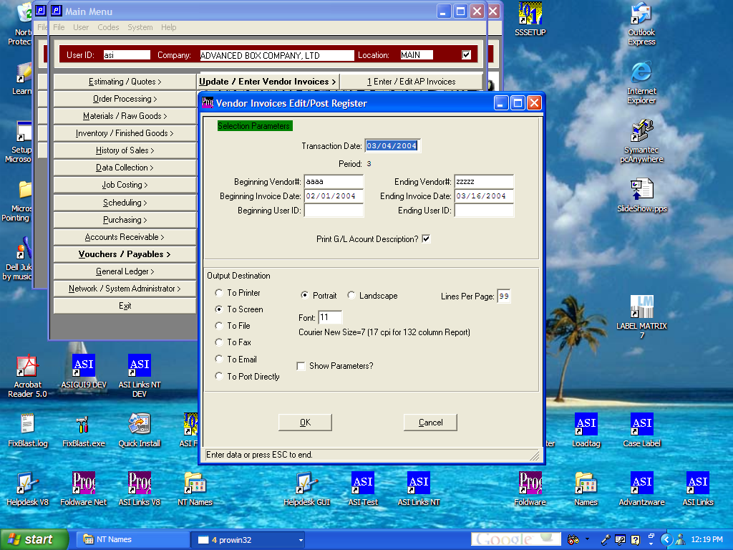

SELECTION PARAMETERS SAVED BY USER ID

The green block highlighting the selection parameter indicates that the print selections are saved by user ID. Therefore, the parameters need not be remembered the next time that you run this program. Eventually, every report and posting register will save your printer selection criteria. Just look for the green block, which indicates that we have changed the program to remember your individual selections.

